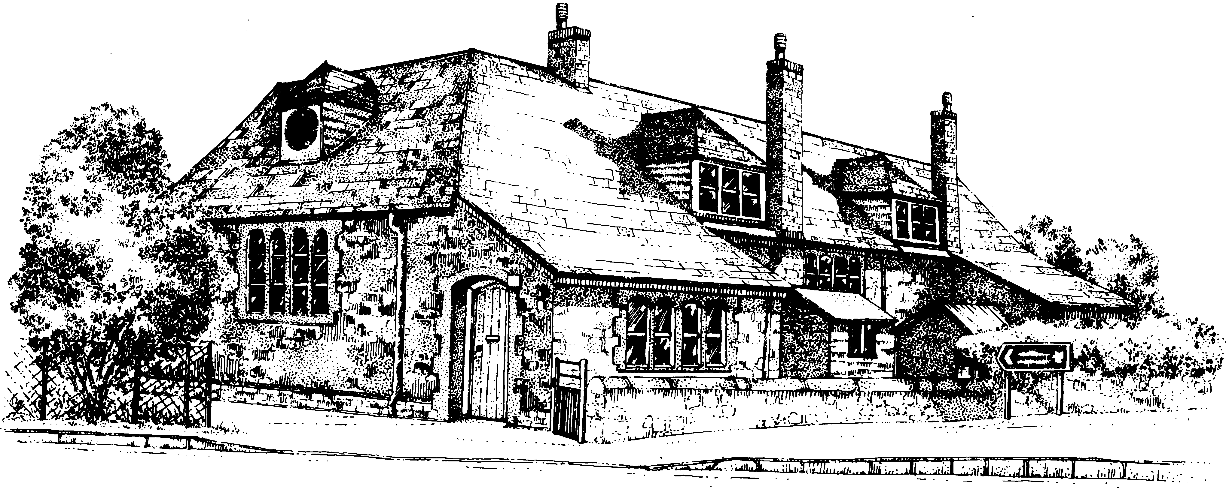
Bolham Primary School

List of Governors Including Vacancies – 25th May 2017
GOVERNOR | TYPE | POSITION | APPOINTED BY | TERM OF OFFICE | COMMITTEES | Registered Interests
Miss Hannah Alford | COO |  | Governing Body | 09/12/2016 – 08/12/2020 | Resources  Performance & Pay | Employed by Michelmores LLP
Mrs Gillian Yvonne Beach  (Stepped down) | STF |  | Teaching & Support staff | 15/10/2014 – 13/07/2016
Mr Christopher Burgess | COO |  | Governing Body | 18/05/2017 – 17/05/2021 | Teaching & Learning,
Mr Martin Cossey  (Stepped down) | PAR |  | Parents | 27/02/2014 – 10/02/2016
Mrs Tracy Cullerne | PAR |  | Parents | 29/06/2016 – 28/06/2020 | Resources,  Performance & Pay
Mr Neal Vincent Davey | LEA |  | Local Authority | 04/03/2015 – 03/03/2019 | Resources,  Performance & Pay | Employed by Devon County Council. Member of Mid Devon District Council. Member of Tiverton Town Council . Trustee/Director of Tiverton Adventure Playgound. Trustee/Director of Moorhayes Community Centre. Director of Tiverton Portas Company
Mrs Abi Dent | PAR |  | Parents | 31/10/2013 – 30/10/2017 | Teaching & Learning (Chair)  AEG (Chair)  Performance & Pay
Mrs Sarah Kay Flower | STF |  | Teaching & Support staff | 19/09/2016 – 18/09/2020 | Teaching & Learning
Rev’d Stephanie Kathleen Jeffs (Stepped down) | COO |  | Governing Body | 16/07/2015 – 06/09/2016
Mr Steven Leather | COO |  | Governing Body | 16/07/2015 – 15/07/2019 | Resources,  Performance & Pay
Mr Stephen Moakes | FOU | Chair | Governing Body | 04/03/2015 – 03/03/2019 | Teaching & Learning | Tiverton Co-Operative Learning Partnership
Miss Stephanie Rolfe | PAR | Vice-chair | Parents | 31/10/2013 – 30/10/2017 | Resources (Chair),  Performance & Pay (Chair)  AEG
Mrs Vera Laura Southcombe  (Stepped down) | FOU |  | Governing Body | 27/09/2013 – 23/03/2017
Mrs Denise Woodgate | STH |  | ex-officio | 01/09/2011 - | Resources,  Teaching & Learning  AEG | Tiverton Co-Operative Learning Partnership
VACANT | FOU

COMPOSITION
You can contact the School Governors by email: admin@tiverton-bolham-primary.devon.sch.uk

TYPE Description Number
COO Co-opted 3
FOU Foundation 2
LEA Local Education Authority 1
PAR Parent 3
Headteacher 1
STF Staff 1
ATTENDANCE | FGB |  |  |  | RES |  |  |  | T&L |  |  |  | P&P |  |  |  | AEG |  |  |  | TOTALS
AT MEETINGS | 2015-6 |  | 2016-7 |  | 2015-6 |  | 2016-7 |  | 2015-6 |  | 2016-7 |  | 2015-6 |  | 2016-7 |  | 2015-6 |  | 2016-7 |  | 2015-6 |  | 2016-7
 | P | A | P | A | P | A | P | A | P | A | P | A | P | A | P | A | P | A | P | A | P | A | P | A
H ALFORD | 0 | 0 | 4 | 4 | 0 | 0 | 3 | 3 | 0 | 0 | 0 | 0 | 0 | 0 | 0 | 0 | 0 | 0 | 0 | 0 | 0 | 0 | 7 | 7
G BEACH | 7 | 6 | 0 | 0 | 1 | 1 | 0 | 0 | 3 | 3 | 0 | 0 | 0 | 0 | 0 | 0 | 0 | 0 | 0 | 0 | 11 | 10 | 0 | 0
M COSSEY | 3 | 1 | 0 | 0 | 3 | 3 | 0 | 0 | 0 | 0 | 0 | 0 | 1 | 1 | 0 | 0 | 0 | 0 | 0 | 0 | 7 | 5 | 0 | 0
T CULLERNE | 1 | 1 | 5 | 4 | 1 | 1 | 5 | 4 | 0 | 0 | 0 | 0 | 0 | 0 | 3 | 2 | 0 | 0 | 2 | 2 | 2 | 2 | 15 | 12
N DAVEY | 7 | 6 | 5 | 4 | 7 | 5 | 5 | 3 | 0 | 0 | 0 | 0 | 2 | 2 | 3 | 3 | 0 | 0 | 0 | 0 | 16 | 13 | 13 | 10
A DENT | 7 | 7 | 5 | 5 | 2 | 2 | 0 | 0 | 3 | 2 | 2 | 2 | 0 | 0 | 0 | 0 | 3 | 3 | 2 | 2 | 15 | 14 | 9 | 9
S FLOWER | 0 | 0 | 5 | 5 | 0 | 0 | 0 | 0 | 0 | 0 | 2 | 2 | 0 | 0 | 0 | 0 | 0 | 0 | 0 | 0 | 0 | 0 | 7 | 7
S JEFFS | 7 | 5 | 0 | 0 | 0 | 0 | 0 | 0 | 3 | 1 | 0 | 0 | 0 | 0 | 0 | 0 | 2 | 2 | 0 | 0 | 12 | 8 | 0 | 0
S LEATHER | 7 | 6 | 5 | 4 | 7 | 6 | 5 | 5 | 0 | 0 | 0 | 0 | 2 | 2 | 3 | 3 | 0 | 0 | 0 | 0 | 16 | 14 | 13 | 12
S MOAKES | 7 | 7 | 5 | 5 | 2 | 2 | 0 | 0 | 3 | 1 | 2 | 1 | 0 | 0 | 0 | 0 | 0 | 0 | 0 | 0 | 12 | 10 | 7 | 6
S ROLFE | 7 | 6 | 5 | 5 | 7 | 7 | 5 | 5 | 0 | 0 | 0 | 0 | 2 | 2 | 3 | 3 | 3 | 3 | 2 | 2 | 19 | 18 | 15 | 15
V SOUTHCOMBE | 7 | 7 | 3 | 1 | 1 | 1 | 0 | 0 | 3 | 3 | 2 | 1 | 2 | 1 | 2 | 1 | 0 | 0 | 0 | 0 | 13 | 12 | 7 | 3
D WOODGATE | 7 | 6 | 5 | 4 | 7 | 6 | 5 | 4 | 3 | 2 | 2 | 2 | 1 | 1 | 2 | 2 | 3 | 3 | 2 | 2 | 21 | 18 | 16 | 14
2015-6 FULL YEAR |  |  |  | FGB Full Governing Body |  |  |  |  |  |  | RES Resources Committee
2016-7 Year To Date (24/05/17) |  |  |  |  |  |  |  |  |  |  | T&L Teaching & Learning Committee
 |  |  |  |  |  |  |  |  |  |  | P&P Performance & Pay Committee
P (PLANNED) A (ATTENDED) |  |  |  |  |  |  |  |  |  |  | AEG Action Evaluation Group

