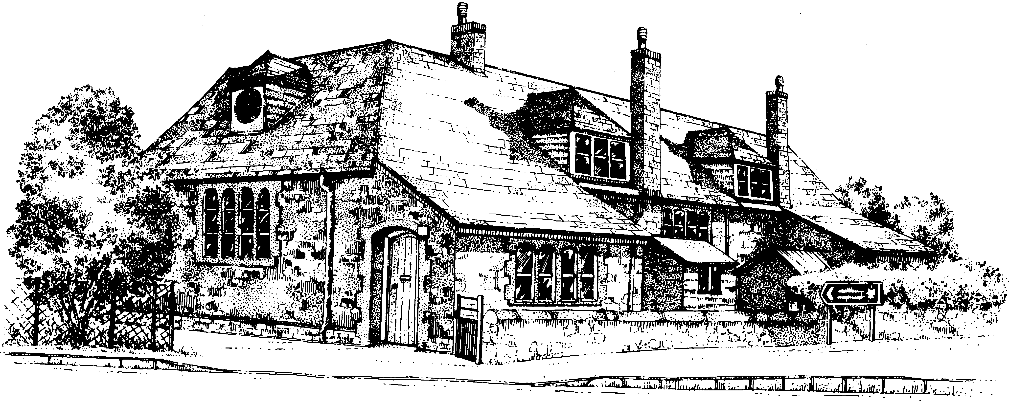
BOLHAM PRIMARY SCHOOL

SCHOOL BREAKFAST AND AFTER-SCHOOL CLUB
PRICE LIST 2018

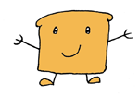
Breakfast Club 7.45am - 8.45am (Breakfast included if required)
£5 per full session
£3 per half session (8.15am-8.45am)

After School Club 3.30pm-5.30pm (Snack included if required)
£3.00 per child - half hour session (3.30pm - 4.00pm)
£5.00 per child - one hour session (3.30pm - 4.30pm)
£6.00 per child - one and a half hour session (3.30pm-5.00pm)
£7.00 per child - two hour session (3.30pm - 5.30pm)

