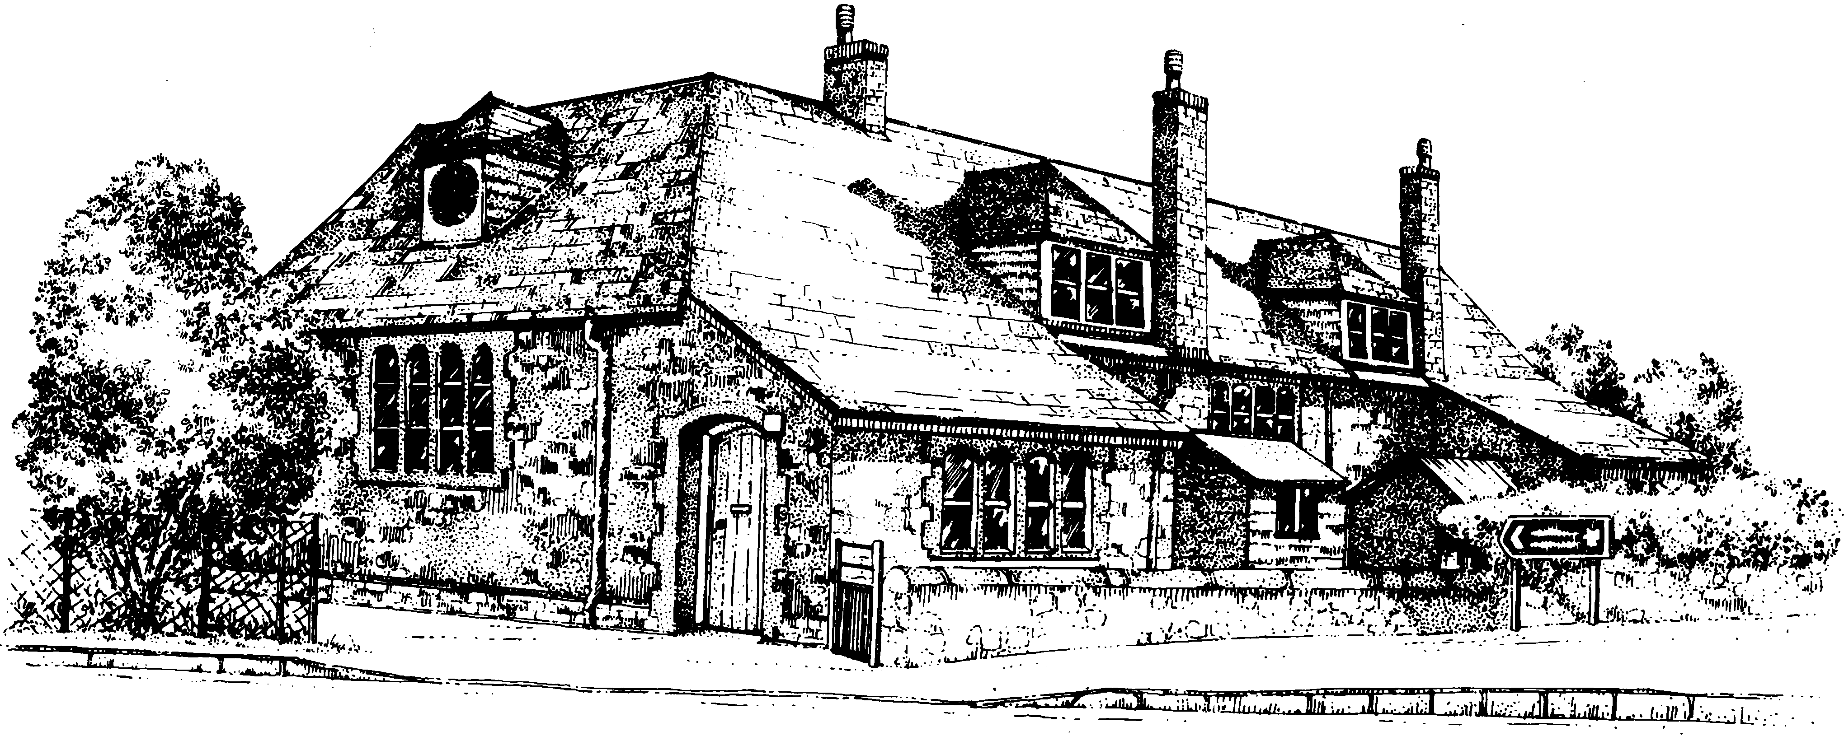
Bolham Primary School

List of Governors Including Vacancies – 2nd January 2019
GOVERNOR | TYPE | POSITION | APPOINTED BY | TERM OF OFFICE | COMMITTEES | Registered Interests
Mr Christopher Burges  (Stepped down) | COO |  | Governing Body | 18/05/2017 – 15/12/2018
Mrs Pamela Ann Cook | COO | Vice-chair | Governing Body | 19/10/2017 – 18/10/2021 | Teaching & Learning, Performance & Pay
Mrs Tracy Cullerne | PAR |  | Parents | 29/06/2016 – 28/06/2020 | Resources,  Performance & Pay, AEG
Mr Neal Vincent Davey  (Stepped down) | LEA |  | Governing Body / Local Authority | 04/03/2015 – 11/07/2018
Mrs Abi Dent | PAR |  | Parents | 31/10/2017 – 30/10/2021 | Teaching & Learning (Chair)  AEG (Chair) | Exeter Northcott Theatre Company
Mrs Sarah Kay Flower | STF |  | Teaching & Support staff | 19/09/2016 – 18/09/2020 | Teaching & Learning
Mrs Claudette Harrower | LEA |  | Governing Body / Local Authority | 26/07/2018 – 25/07/2022 | Resources,  Performance & Pay | Tiverton Town Council
Mr Stephen Moakes | FOU | Chair | Governing Body/Tiverton Co-operative Learning Partnership | 04/03/2015 – 03/03/2019 | Teaching & Learning | Tiverton Co-Operative Learning Partnership
Miss Stephanie Rolfe | FOU |  | Governing Body/Tiverton Co-operative Learning Partnership | 31/10/2017 – 30/10/2021 | Resources (Chair),  Performance & Pay (Chair)  AEG | Tiverton Co-Operative Learning Partnership
Mrs Julia Slade | PAR |  | Parents | 31/10/2017 – 30/10/2021 | Resources,  Performance & Pay
Mrs Denise Woodgate | STH |  | ex-officio | 01/09/2011 - | Resources,  Teaching & Learning, AEG | Tiverton Co-Operative Learning Partnership
Vacancy x 2 | COO
COMPOSITION
TYPE Description Number TYPE Description Number
COO Co-opted 3 FOU Foundation 2
LEA Local Education Authority 1 PAR Parent 3
Headteacher 1

ATTENDANCE | FGB |  |  |  | RES |  |  |  | T&L |  |  |  | P&P |  |  |  | AEG |  |  |  | TOTALS
AT MEETINGS | 2017-8 |  | 2018-9 |  | 2017-8 |  | 2018-9 |  | 2017-8 |  | 2018-9 |  | 2017-8 |  | 2018-9 |  | 2017-8 |  | 2018-9 |  | 2017-8 |  | 2018-9
 | P | A | P | A | P | A | P | A | P | A | P | A | P | A | P | A | P | A | P | A | P | A | P | A
C BURGESS | 6 | 5 | 2 | 0 | 0 | 0 | 0 | 0 | 3 | 1 | 1 | 0 | 0 | 0 | 0 | 0 | 2 | 2 | 1 | 1 | 11 | 8 | 4 | 1
P COOK | 6 | 5 | 2 | 2 | 0 | 0 | 0 | 0 | 3 | 3 | 1 | 1 | 2 | 1 | 1 | 1 | 0 | 0 | 0 | 0 | 11 | 9 | 4 | 4
T CULLERNE | 6 | 6 | 2 | 2 | 6 | 5 | 2 | 2 | 0 | 0 | 0 | 0 | 2 | 2 | 1 | 1 | 2 | 2 | 1 | 1 | 16 | 15 | 6 | 6
N DAVEY | 6 | 1 | 0 | 0 | 6 | 1 | 0 | 0 | 0 | 0 | 0 | 0 | 2 | 0 | 0 | 0 | 0 | 0 | 0 | 0 | 14 | 2 | 0 | 0
A DENT | 6 | 5 | 2 | 2 | 0 | 0 | 0 | 0 | 3 | 2 | 1 | 1 | 0 | 0 | 0 | 0 | 2 | 2 | 1 | 0 | 11 | 9 | 4 | 3
S FLOWER | 6 | 6 | 2 | 2 | 0 | 0 | 0 | 0 | 3 | 3 | 1 | 1 | 0 | 0 | 0 | 0 | 2 | 2 | 1 | 1 | 11 | 11 | 4 | 4
C HARROWER | 6 | 6 | 2 | 2 | 5 | 4 | 2 | 1 | 0 | 0 | 0 | 0 | 2 | 0 | 1 | 0 | 0 | 0 | 0 | 0 | 13 | 10 | 5 | 3
S MOAKES | 6 | 5 | 2 | 2 | 0 | 0 | 0 | 0 | 3 | 3 | 1 | 1 | 0 | 0 | 0 | 0 | 0 | 0 | 0 | 0 | 9 | 8 | 3 | 3
S ROLFE | 6 | 6 | 2 | 2 | 6 | 6 | 2 | 2 | 0 | 0 | 0 | 0 | 2 | 2 | 1 | 1 | 2 | 2 | 1 | 1 | 16 | 16 | 6 | 6
J SLADE | 5 | 4 | 2 | 1 | 5 | 5 | 2 | 2 | 0 | 0 | 0 | 0 | 2 | 1 | 1 | 1 | 0 | 0 | 0 | 0 | 12 | 10 | 5 | 4
D WOODGATE | 6 | 6 | 2 | 2 | 6 | 6 | 2 | 2 | 3 | 3 | 1 | 1 | 2 | 2 | 1 | 1 | 2 | 1 | 1 | 1 | 19 | 18 | 7 | 7
2017-8 FULL YEAR |  |  |  | FGB Full Governing Body |  |  |  |  |  |  | RES Resources Committee
2018-9 to date |  |  |  | AEG Action Evaluation Group |  |  |  |  |  |  | T&L Teaching & Learning Committee
P (PLANNED) |  |  |  |  |  |  |  |  |  |  | P&P Performance & Pay Committee
A (ATTENDED)

